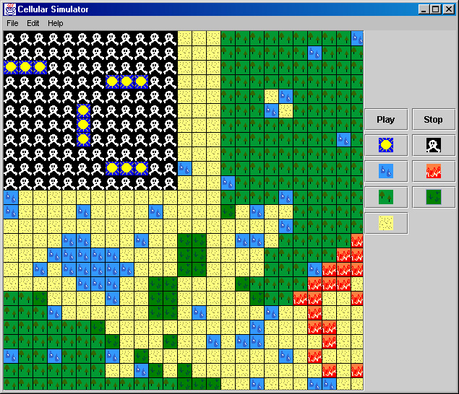

Cellular Simulator

Developed By:

Jeffrey Miller
Michael Wales
User Manual for Cellular Simulator

Table of Contents

- Purpose and Uses of This Product
- Installation Instructions
- How to Add States
- How to Edit Transition Rules
- How to Edit the Initial State Map
- How to Load and Save Simulations
- How to Run Simulations
- Guidelines on Reprogramming State Transition Rules
- Troubleshooting
Purpose and Use of This Product

The design of this program is inspired by many of the Cellular Automata simulations on the Internet. Most simulators simply have an implementation of "Conway's Game of Life", and the user can edit the initial states of the simulation. Our product does this and more. The user can edit the initial states, add different states, change the rules of the simulation, load and save simulations, and the program also provides an easy way to reprogram the transition rules so the user can create their own complex rules.
The program was developed for Dr. Moshell in the Fall of 2000 for Dr. Franceschini's Software Engineering (EEL5881) class. It was developed by two undergraduate Computer Engineering students: Jeffrey Miller and Michael Wales. The program is the sole property of the University of Central Florida. The program was developed using Sun Microsystems' Java 2 V1.3 SDK and will run under the Java 2 JRE V1.3. Both products are the property of Sun Microsystems and are available for free download at their website.

Installation Instructions

Cellular Simulator runs using the Java Runtime Environment (JRE). Platforms currently supported by the JRE include: PC, Macintosh, Linux, Irix, Solaris, and many others. This installation guide is geared towards installation on a PC with the Windows operating system (95 or later).

Step 1: Install the JRE
You will first need to download the JRE from Sun's website (www.java.sun.com). We would recommend users to use the Java 2 V1.3 runtime environment. If users wish to try programming their own transitions, they will need to download the Java 2 V1.3 SDK, which will include the JRE. At Sun's website, click on "Products & APIs" on the left-hand side of the webpage. When the next page comes up, click on the box in the middle and select which product you would like: "Java 2 Runtime Environment, Standard Edition, v 1.3" for strictly the JRE or "Java 2 SDK, Standard Edition, v 1.3" for the complete development environment and the JRE.
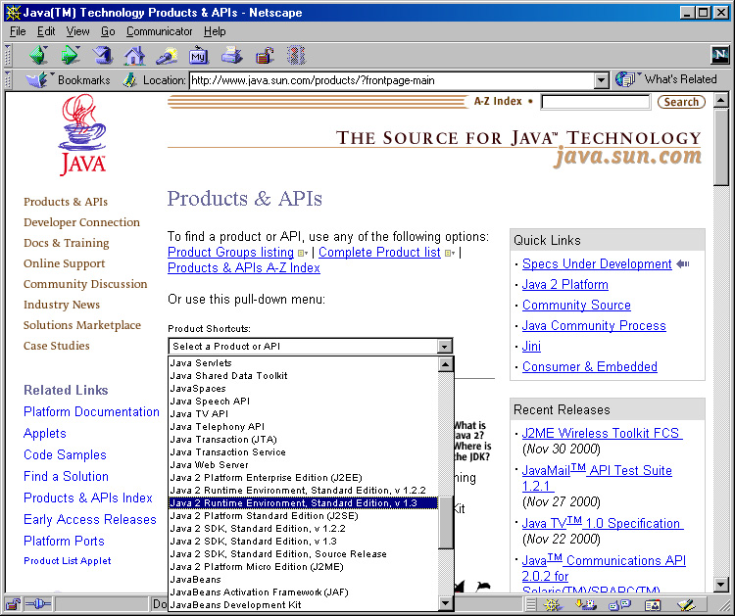

Then follow the instructions provided on Sun's website as to how to install the product on your particular operating system. If you are using a computer that does not have Internet access, you can use the Java 2 SDK V1.3 that is provided on the CD-ROM (look in the Java directory). This is not recommended because Sun is constantly improving the JRE with performance and security updates that will not be present on the CD-ROM.

Step 2: Copy the program files from the CD-ROM
You will next need to copy the files from the CD-ROM into a directory on your hard drive. All the .class and .java files need to be kept in the same directory for the program to work properly.

Step 3: Test the installation
To test the program under Windows, start a new "MS-DOS Prompt" application. Go to the directory where the program is located.

If you are simply using the JRE, type the following:
- java CSim

If you are using the SDK and want to test the compiling features, type the following:
- del *.class
- javac CSim.java
- java CSim

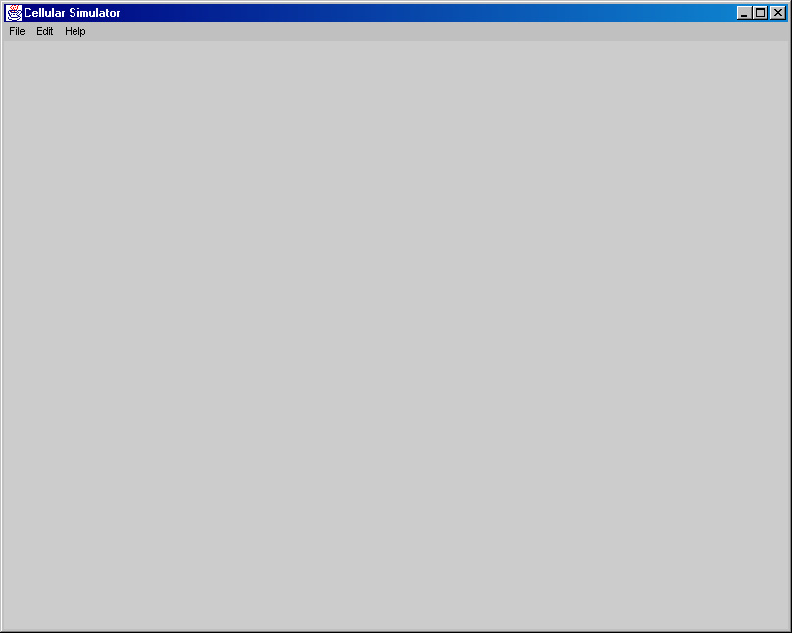
The end result of both operations should be a screen that looks like the following:
How to Add States

The first step to creating a new simulation is to create some new states for the simulator. It is not possible to save the simulation, to edit the map, or to change the rules without having any states. First, go to the state and transition properties window by clicking "Edit Transitions..." under the Edit menu bar. The following will pop up on your screen:
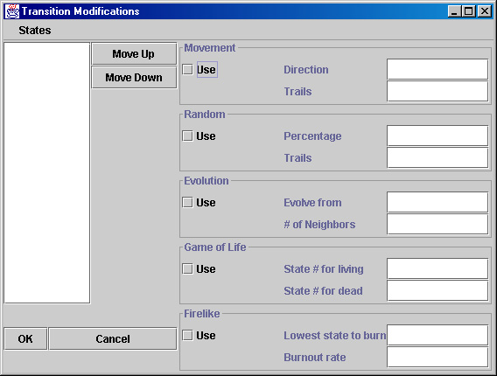
The white field on the left-hand side of the window is the list of states. Since we have not created any states yet, the list is empty. The five boxes on the right hand side of the screen are the five different available rules. Each state can choose to use any combination of the five rules for the simulation. There is a later section in the manual on how the rules work.
To create a new state you will need to select "Add A New State..." from the States menu. Another dialog box will pop up prompting the user to enter a name for their new state. The user then clicks OK to accept the state's name, or cancel to abort the operation.
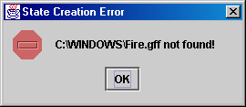
After the user clicks OK, a file selection box will pop up so the user can pick the image to associate with the state. Valid images are .GIF, .TIF, .JPG, and .BMP. Also, the program requires the size of the image be 20 by 20 pixels. If you try to select an invalid file format, or an image with the incorrect size, the program will inform you of the problem.
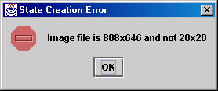
Once the image is loaded correctly, the new state will appear on the list. Many states can be used in a simulation (up to 20). If the need to remove a state occurs, select the state in the list by clicking on it, and then select "Delete State" from the State menu. Please note it is not possible to delete all the states in the list; you have to have at least two states to be able to use the delete function.
Another feature of the state list is the two buttons beside it. The states all have precedence in the simulation. A state that is highest on the list, which is state number 0, has the highest precedence (state precedence will be elaborated on later). By selecting a state, and pressing the Move Up and Move Down buttons, you can define the order of your state's precedence.
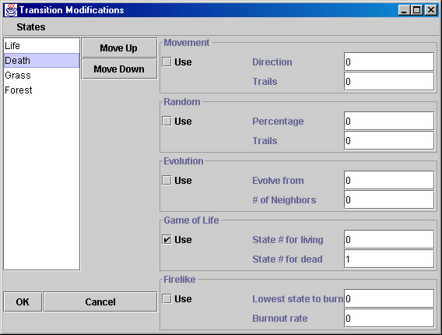
How to Edit Transition Rules

To run a simulation, you need to provide the simulator the information on how the cells should act during the simulation. Each state can have it's own unique set of rules to govern how it will act during a simulation. The five rules that come with our program distribution are discussed below.

Movement
When this option is checked, each cell will have the appearance of movement. The direction can be any multiple of 90 degrees ranging from –360° to 360°. The directions are set up like a polar coordinate system. 90° will move the cells up, 270° or -90° will move the cells downwards. The second parameter, trails, is to tell the simulator if a trail of the state will be left behind. An entry of 1 represents true, which will leave a trail of cells behind. An entry of 0, will represent false, and will not leave a trail behind. If it sounds confusing, try both settings, and the difference will easily become apparent.

Random
Just as the name implies, this rule will provide for random growth anywhere on the map. The percentage parameter tells the simulator the percent chance that a cell will randomly become a particular state. A 100 here will indicate to the simulator that this particular state will go everywhere, but this does not necessarily mean that the simulator will put this state everywhere. If the particular state is low on the precedence list, things can go on top of it and over rule the state. For example, sand in a forest simulation, will be found anywhere where everything else is absent. The user could put sand as the lowest state on the precedence list (anything can grow on top of it if it wants to), and set its percentage to 100 (it will be everywhere).
The second parameter is trails. This works very similarly to the movement rule. In fact, you can set the percentage to zero (no randomness), and trails to 1, to create trails for any state, whether or not it's other rules provide a parameter for trails. When trails is equal to 1 and the simulator is running, every time it encounters the particular state in the last cycle, it draws it in the same place for the next cycle.

Evolution
Evolution provides a way that a new state can form in the surroundings of another state. For instance, you could evolve a cell that is surrounded in grass to a forest state, if four of its neighbors are grass. Neighbors include the cells above, below, to the left, and to the right. The first parameter is the state number on the list that the selected state will evolve from. Remember, the states are number from 0, starting at the top. The second parameter is the number of neighbors (up to 4) that are needed to trigger an evolution. Please note that state corresponding to the state number in the first parameter, and the current state that the rule pertains too, are both considered adding to the number of neighbors needed to trigger an evolution. It is not solely the state number in the first parameter.

Game of Life
This rule is used to simulate John Conway's "Game of Life". Life has the following two rules and only these two rules: (1) A living cell will continue to live if 2 or 3 of its 8 closest neighbors are living, else it will die. (2) A dead cell will come back to life if 3 of its neighbors are living.
This rule was put into the simulator to demonstrate how versatile the simulator is. Our simulator is not specifically a Cellular Automata simulator, but a little something more, that could easily do the Cellular Automata simulation of life.
To simulate the game of life, you will need at least two different states. For each state, select that they will use the "Game of Life" transition rule. In both rule boxes, fill in the corresponding state numbers for the life and death states. These two numbers should be the same for both states, if they are not, the simulation will not work properly. Further details about the uses of the "Game of Life" can be found on the Internet along with some interesting examples.

Firelike
This rule's main purpose is to simulate fire. Real life fires do not burn everything (dirt and water do not burn), and a fire typically will eventually burn out. Modeling those two characteristics is the purpose of the parameters for fire. The first parameter, lowest state to burn, is the state number of the lowest thing on your list that is combustible. For instance, if you have sand as your last state, and that grows everywhere, fire does not really burn sand, although it is higher on the precedence list than sand. This parameter allows the user to keep fire from catching sand on fire.
The second parameter is used to model how long it takes for a fire to burnout. We could have kept track of how long a particular cell was on fire, and then make a decision based on that, but a random number and a percentage works just as well for the typical engineer. The percentage given in the parameter is the percentage that any give fire will just burn out.

Since you now have an idea of how each of the rules work, you can go ahead and start setting up the parameters for each state's rules. Simply click on a state on the left-hand side of the screen, and all the rules and their current settings will appear on the right hand side. Check the use box by each rule that you intend to use, and fill out the parameters for that given rule. Go through each state, and set the rules for each of the states.
WARNING!!! During the simulation, there must be a state at every cell in the map. A cell can not simply become empty. If a cell does become empty somehow in the simulation, the simulator will not work properly. There really is not any way to tell if a set of rules will cause this to happen or not, so the program cannot check for this case. What the user can do to avoid this from ever happening, is to have a state that is the lowest on the precedence list. Set it to use the Random rule, with 100% and 1 as the parameters. This state is guaranteed to be everywhere now. In addition, since it is the lowest state on the list. Any other state can just grow right over it. If you ever happen to get a bunch of error messages in your MS-DOS Prompt window, this could be the cause.

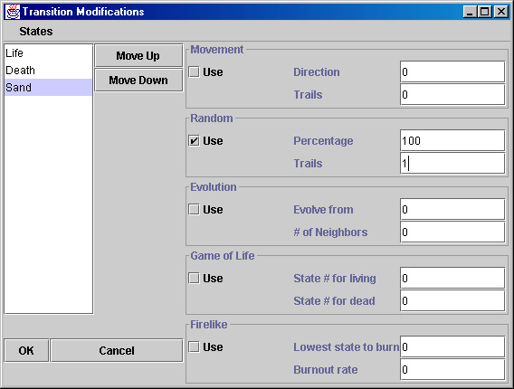
After you finishing changing all the parameters in window, you can click either OK or Cancel. Click OK to accept your new changes, or click Cancel to revert to the rules and states that were used before you went to the transition properties window. You will then come back to the main simulator window after you press one of the buttons. If you already had a map loaded, and you changed many of the states and their order on the state list, the map will probably not be what it was when you left it. This is the normal operation of the program.

How to Edit the Initial State Map

After adding the first states for a simulation, and programming the rules, when you get back to the main simulator window, there is nothing in it. To create a new map, select New from the file menu. The following box will appear for the user to select the size for the state map:
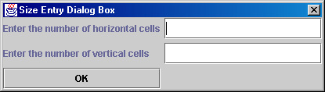
The maximum map size is 45 units wide, and 35 units tall. This works well on the lab computers with resolution 1024x768. After you select OK and the program accepts your parameters you will see:
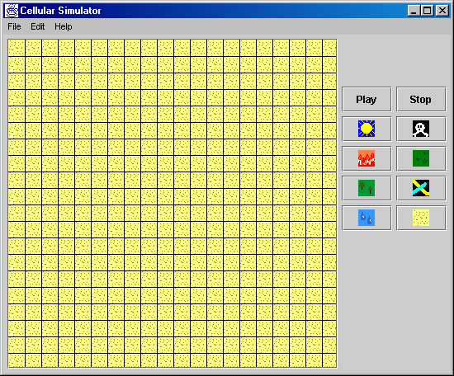

To edit the initial states simply click the button corresponding to the state you would like to add to the map. Then click inside the cell you wish to add the state to. You can also hold down the mouse button and drag the mouse down and right to select multiple boxes.
How to Load and Save Simulations

After the user has created some states and a map, it is then possible to store all the simulation's information to disk. this is accomplished by selectiing "Save As..." from the file menu on the main simulation screen. If the user tries to save a simulation without states or a map, they will be prompted like this:
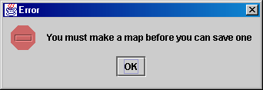
When a file is saved, all the simulation information is saved with it including the current state map, the states, the pictures, and the rule parameters. The saved files can be quite large (over 400k).
To load a file, select "Open..." from the file menu. After the user finds the file and clicks OK, the program will then load all the simulation data for a few seconds. Then the map displayed on the screen just the way it was saved.
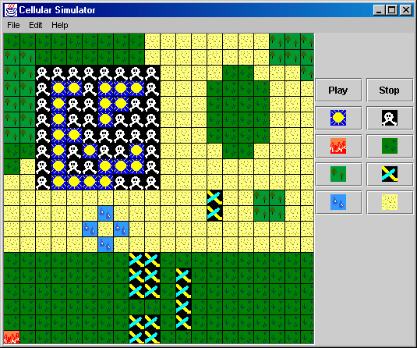
How to Run Simulations

The most exciting part of our simulator is obviously the simulation. It's also the easiest part of the simulator. Just click on the play button, and watch your simulation fly by. There is also a counter at the top of the screen that tells you how long it has simulated for. The stop button will reset the counter, and stop the simulation.
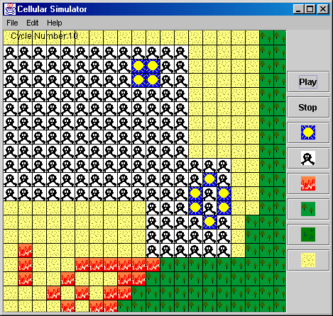

Guidelines on Reprogramming State Transition Rules

To make the program as versatile as possible, we included support for the user to program their own transition rules for the simulator. This section is not for computer novices; the program is only intended to be modified by individuals who have a good grasp of object-oriented programming and Java. We created the program in such a way that to program the transitions, you only need to program one single method. Please note that when you reprogram the transitions, you will probably not be able to load save files, and doing so could crash the program. It is recommended that before you edit any program files, you copy the programs and all the files that belong with that particular version, and move them to an entirely separate directory so there won't be any confusion.
The simulator goes through the map one cell at a time. At each cell, it calls a method which will ask each state if it would like to exist at coordinate (x,y). The method will return true or false based on it's set of rules. The simulator starts by asking the lowest state, and then works it way through the precedence list, the last state returning true will be the state that the cell will transition into.
Each transition rule has it's own .java file. The first rule (Movement) is stored in TransitionA.java. The user can ignore all the methods in that file except for the following one:

boolean willCellTrans ( CellMap SimulationArea, int XCell, int YCell, int SN)

The values XCell and YCell are numbers corresponding to the coordinates of a cell that is being checked by the simulator. The parameter SN is the state number that is actually being checked. The parameter SimulationArea is a class that holds all the information about the current state map. Here is a list of the methods from that class that you can access and what they do:

- int getRandomNumber(int x): This method returns a random number from 0 to x.
- int getXDim(): Returns the horizontal size of the simulation map.
- int getYDim(): Returns the vertical size of the simulation map.
- int getStateNum(int x, int y): Returns the state number for the cell (x,y).
- int getNumberOfStates(): Returns the number of states in the current simulation.

There are a few variables in the transition class that will probably have to be modified when creating new rules. They are below:

- static String Description: The description of the rule that appears on the border of the panel holding the rule.
- static String Param1Description: The text directly in front of the top text field.
- static String Param2Description: The text directly in front of the bottom text field.
- static boolean UseParam1: Tells the program whether or not it should display the top text field and its corresponding description.
- static boolean UseParam2: Tells the program whether or not it should display the bottom text field and its corresponding description.

These are the only methods and variables outside of the function that will be accessed by a transition rule algorithm. The method should return true when it wants the cell to transition to the state, and false when it should not.
To compile the code for the program after making some changes, it's easiest to do the following:

del *.class
javac CSim.java
java CSim

On an unsuccesful compile, all the errors in the program will be displayed after the javac command.

Troubleshooting

PROBLEM: Identical versions of the program on different computers are not able to share saved files.
SOLUTION: Check and make sure that the JREs are identical on both computers. During development, we suspect that some of our problems loading and saving files from different computers were from mixing JRE versions 1.2.2 and 1.3. If that does not work, double check to make sure the transition files are the same on both computers.

PROBLEM: Start to do a simulation with same transitions that are on the disk, and the program fires null pointer errors and / or crashes.
SOLUTION: Transition rules are probably not set up so that every cell is guaranteed to filled up every clock cycle. There can be no "empty" cells. Read page 9 for in-depth solution to this problem.

PROBLEM: Have reprogrammed one of the transitions, and it compiles fine. But when simulation runs, the programs fires "Array index out of bounds" exceptions in one of the classes was not changed.
SOLUTION: The CellMap's methods do not verify that the indexes given to it by your translation class are valid. It is the willTrans method's responsibility to make sure the array indexes are not violated. The getXDim() and getYDim() methods are provided to help with that.

